
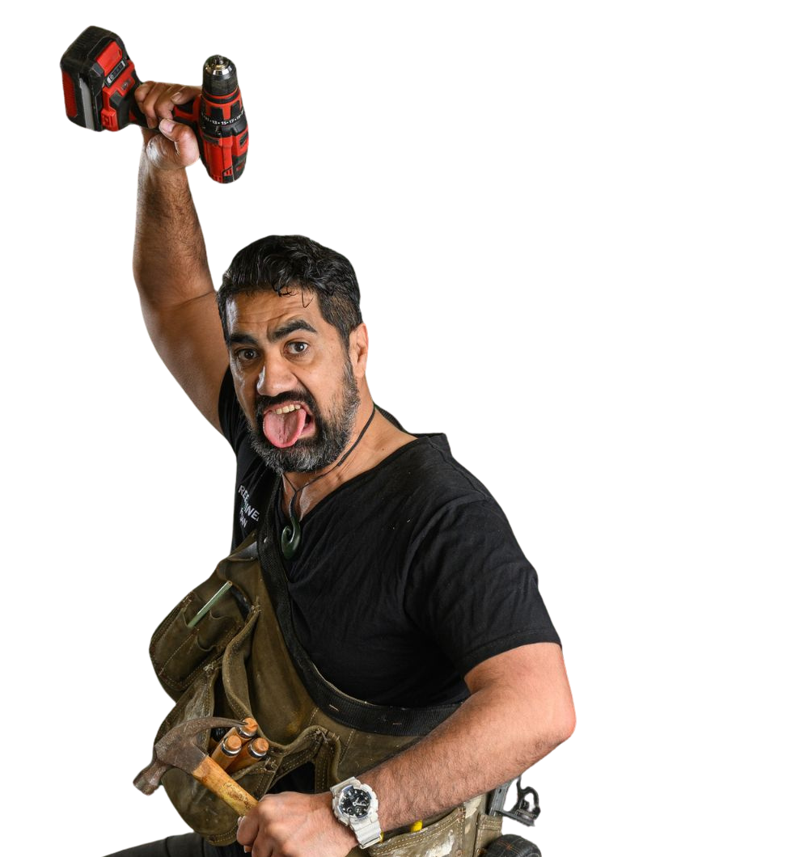
Welcome to Circa Theatre.
This document uses pictures and descriptions, so you know what to expect when you visit Circa Theatre.

VISUAL GUIDE

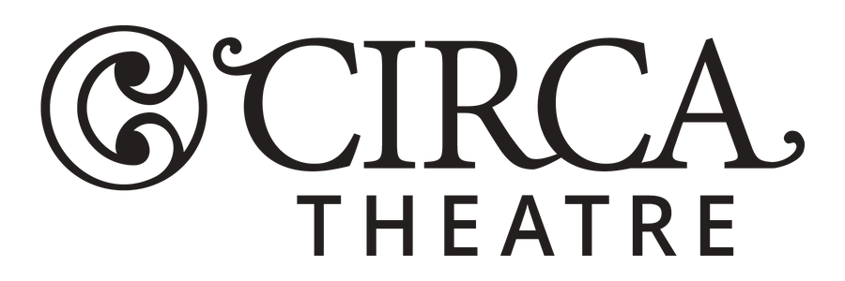

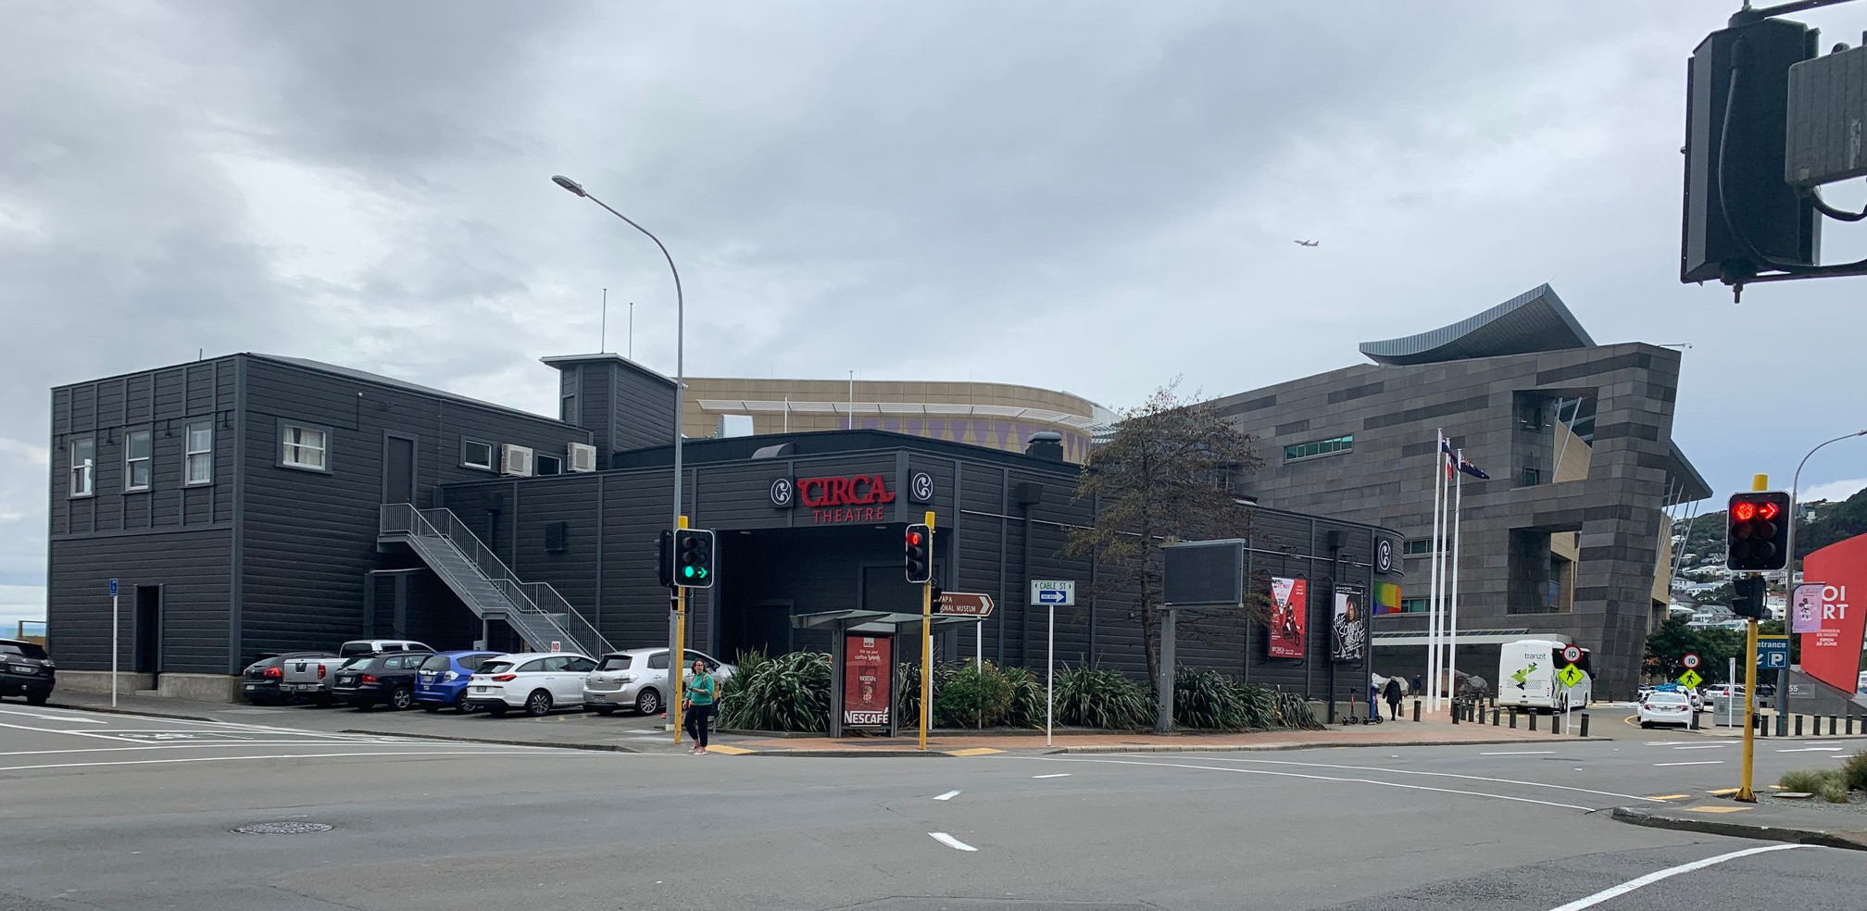

Image 1: Circa Theatre on the intersection of Taranaki Street and Cable Street

Circa is located on the corner of Taranaki Street and Cable Street,
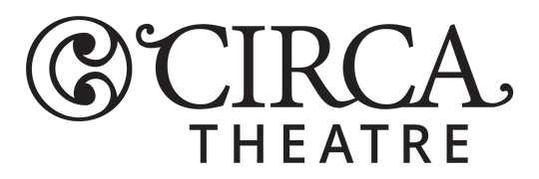
right next door to Te Papa on the Wellington waterfront. Information on parking, nearby bus stops, and drop-off zones can be found on
this accessibility web page.

There are two main entrances to Circa. One is via the new Chouchou restaurant, the entry doors are on the waterfront facing North. You enter through glass double doors in the middle of the outdoor patio.
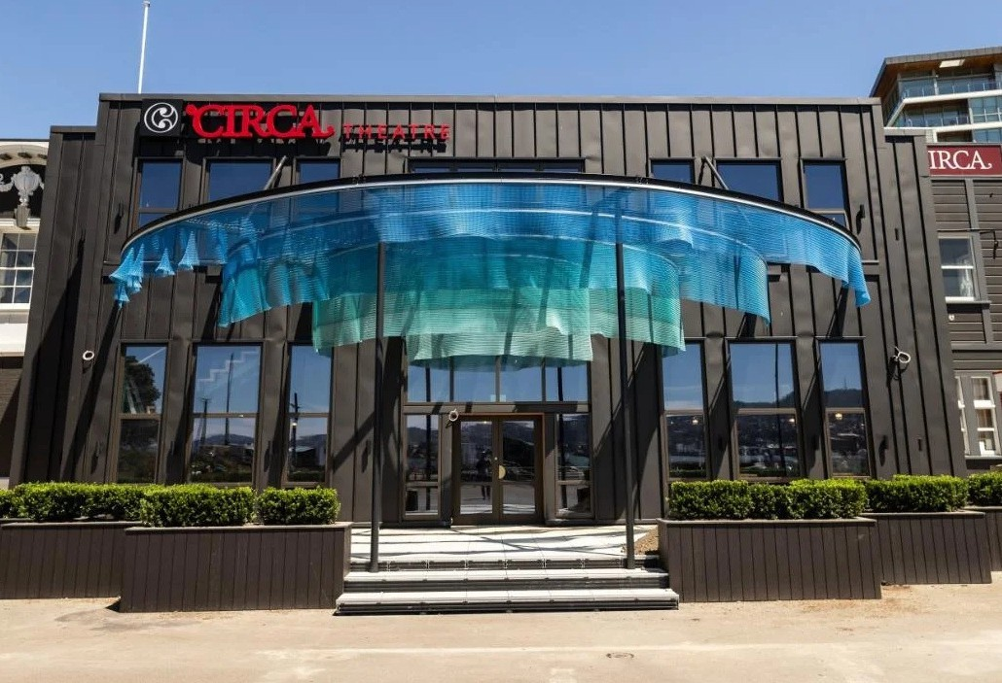
Image 2: A front on view of Circa Theatre and Chouchou the new cafe which faces towards the waterfront.

There are two step free entrance ways on each side of the patio, leading up to the front doors.

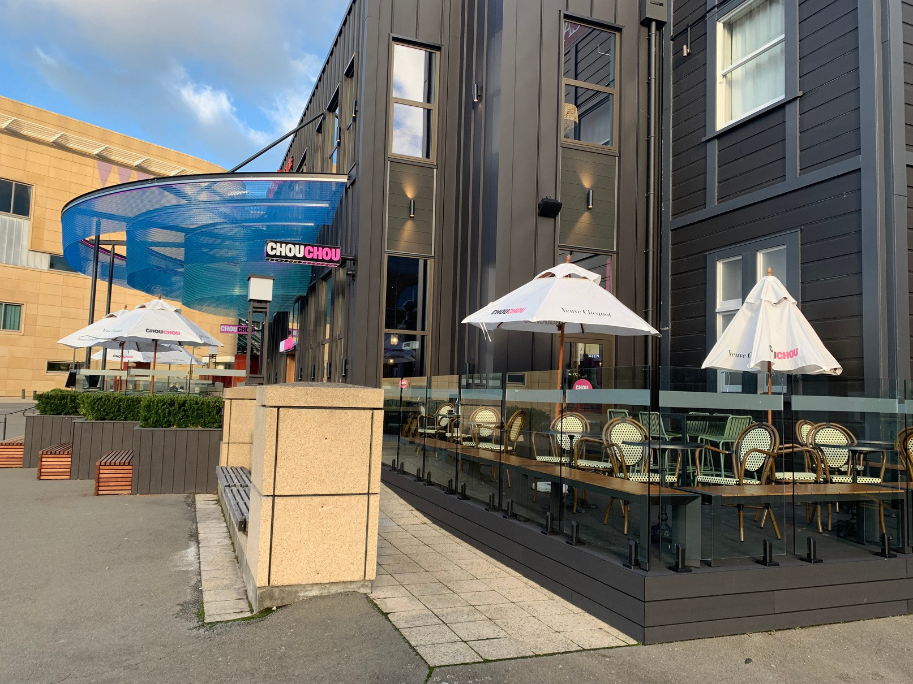
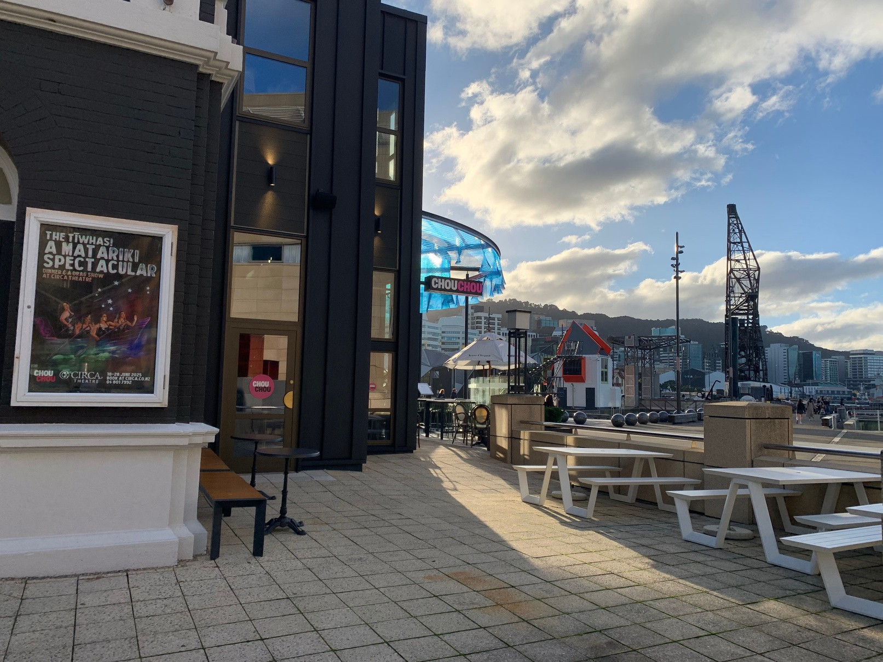
Image 3: Step free access from the Te Papa plaza Image 4: A step free ramp accessed from the waterfront side

Another entranceway faces Te Papa on the east side. It has red wooden double doors. Inside these doors is a 1m x 1m transition space with a second pair of double doors leading into the inside foyer. This entrance is accessible by wheelchair and has a tiny lip step.
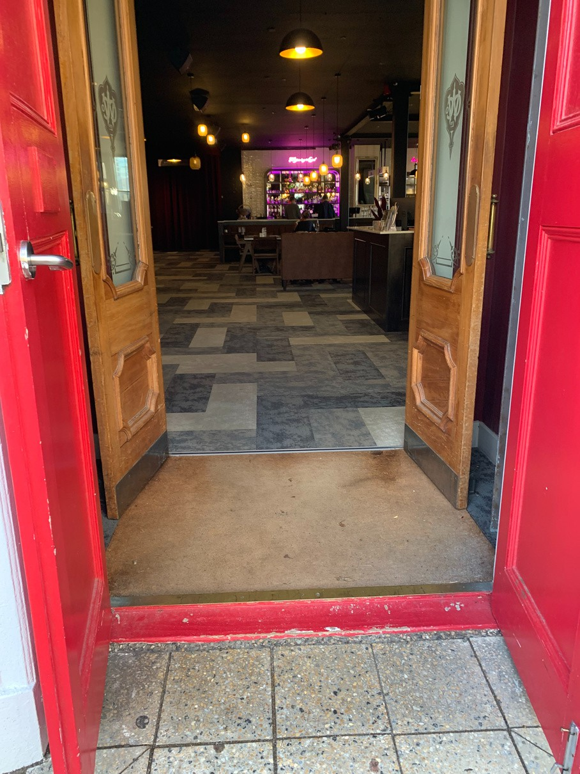
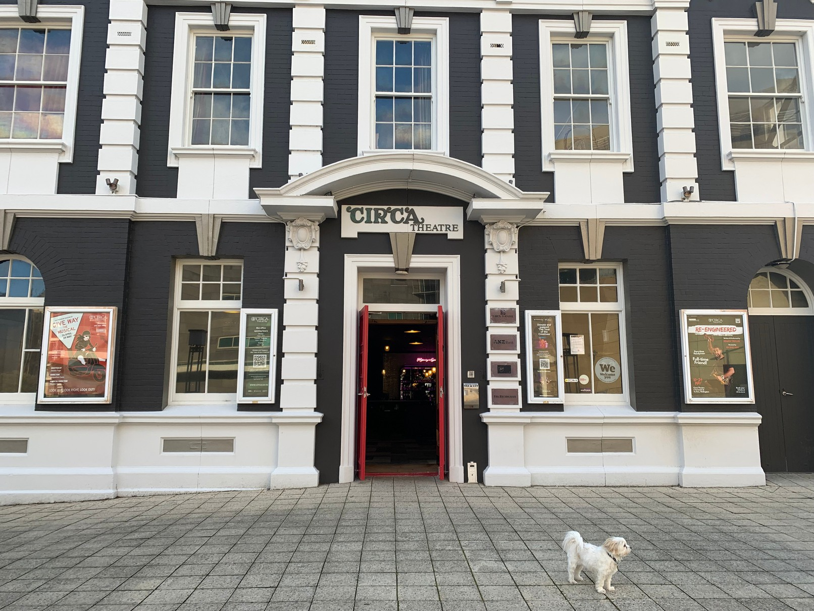
Image 6: Entering through the red doors
Image 5: The red double doors on east side of the Circa Theatre building are facing Te Papa, and that’s Luna the dog standing in front of the building.

When you arrive at Circa via the red doors, you will enter the foyer. The box office is on the right and a small vestibule leading to the toilets is on the left.
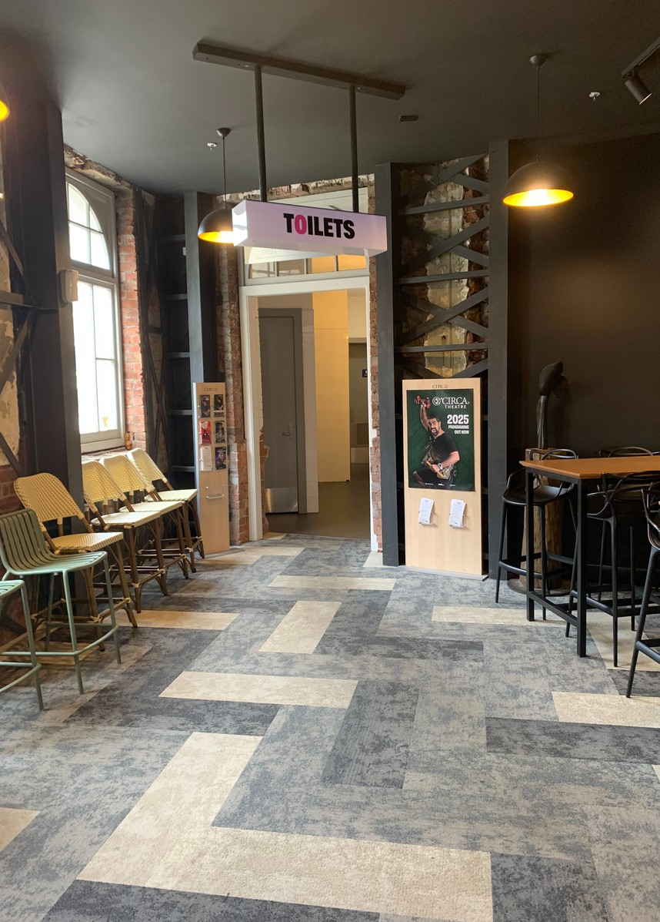
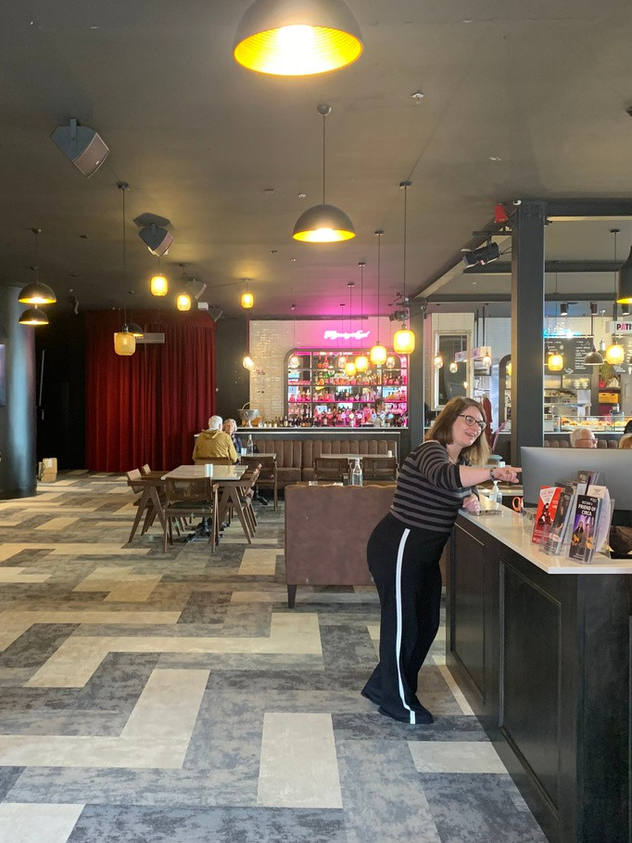
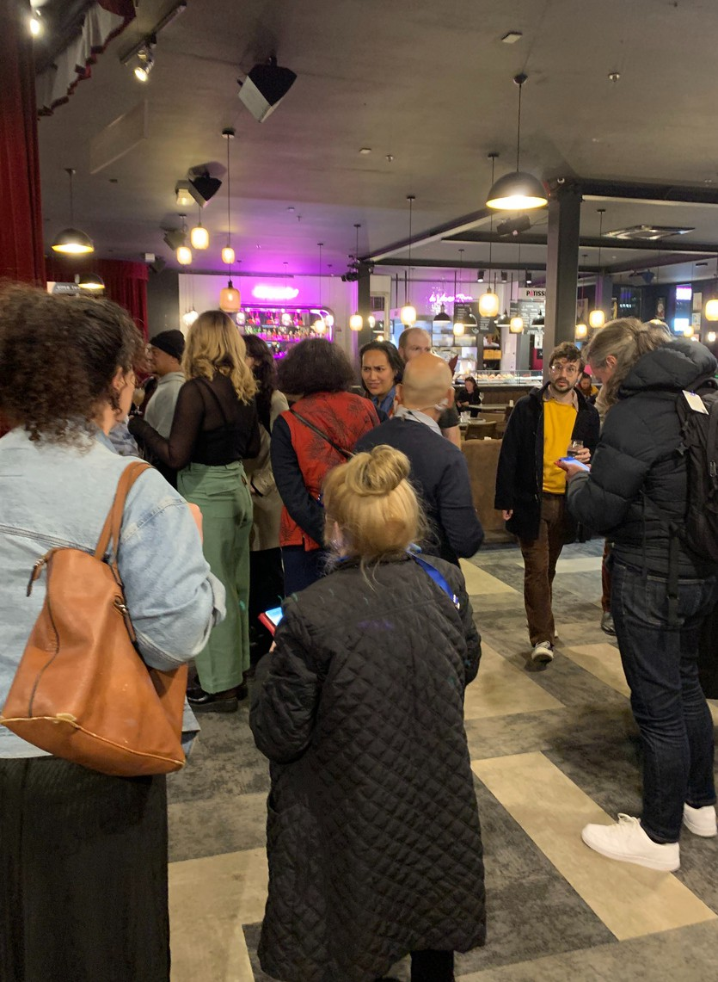

Image 7: The inside foyer with the box office on the left and Chouchou the cafe.
Image 8: A crowd waiting in the foyer outside the theatre, waiting to enter before a performance.
Image 9: The vestibule leading off the front door to the toilets.

Through the vestibule is a corridor that has 3 doors that lead into the men’s, women’s and an accessible toilet.

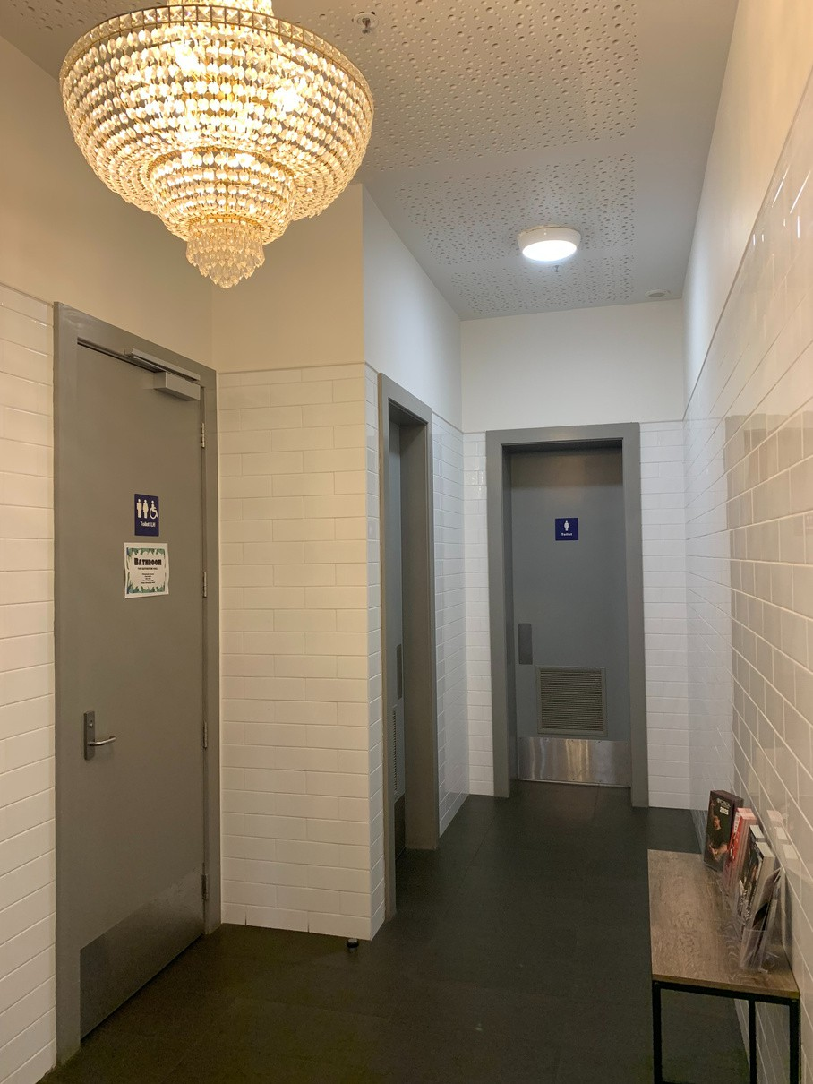
Image 10: Corridor that leads to the toilets

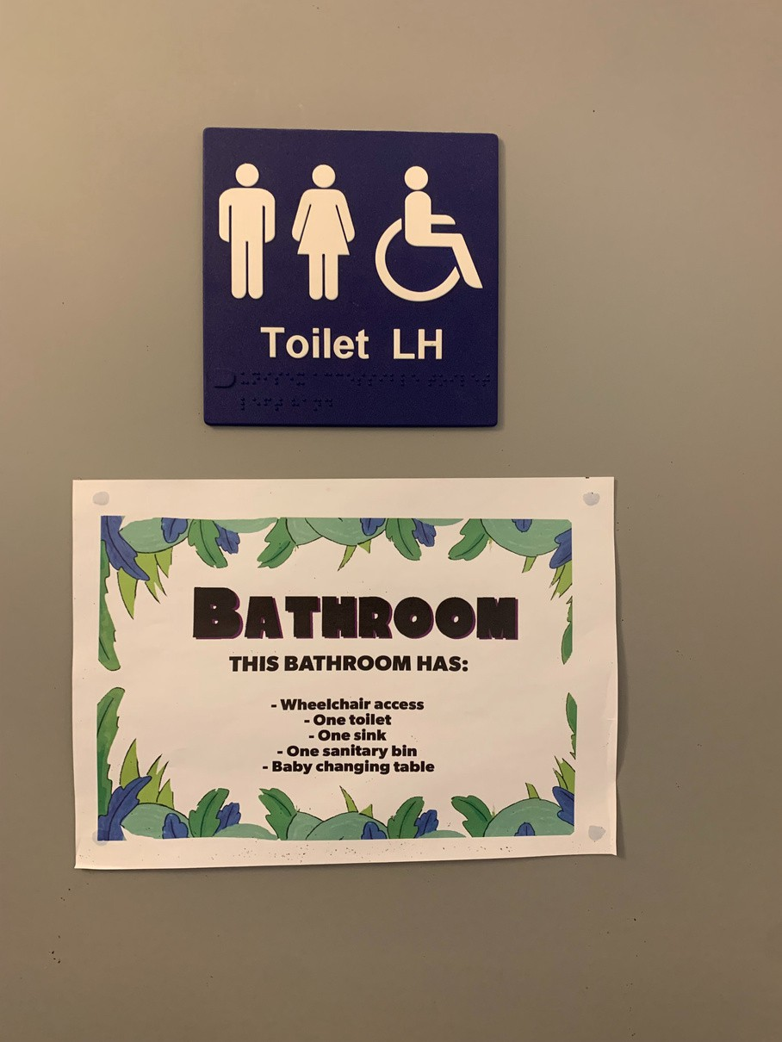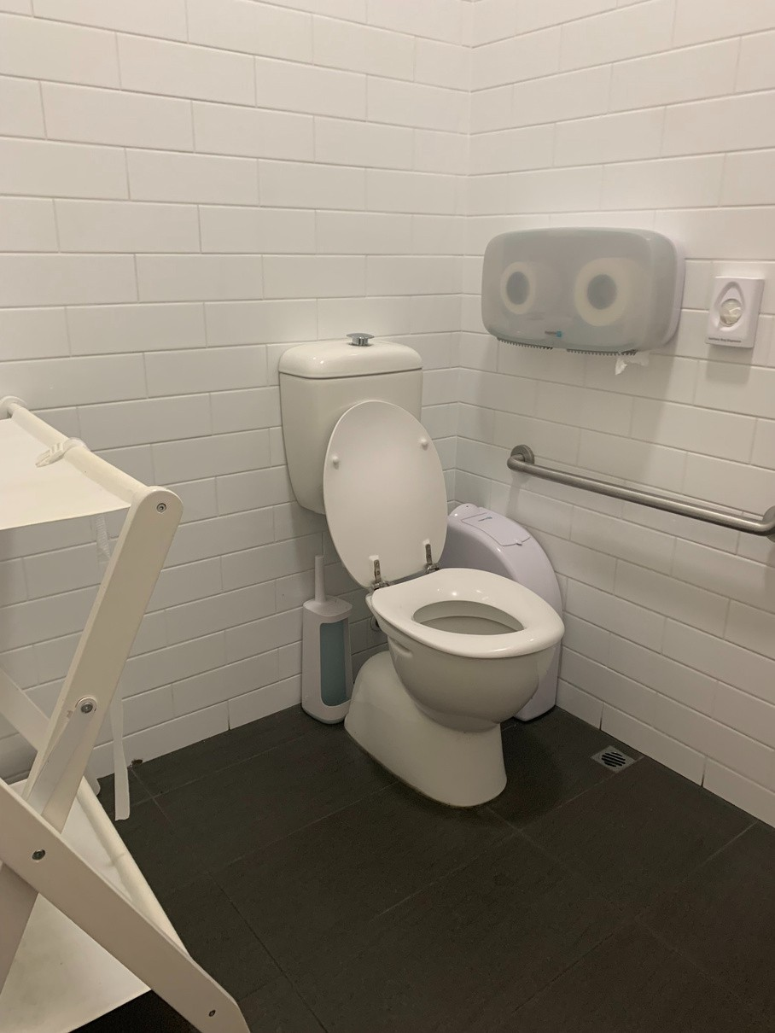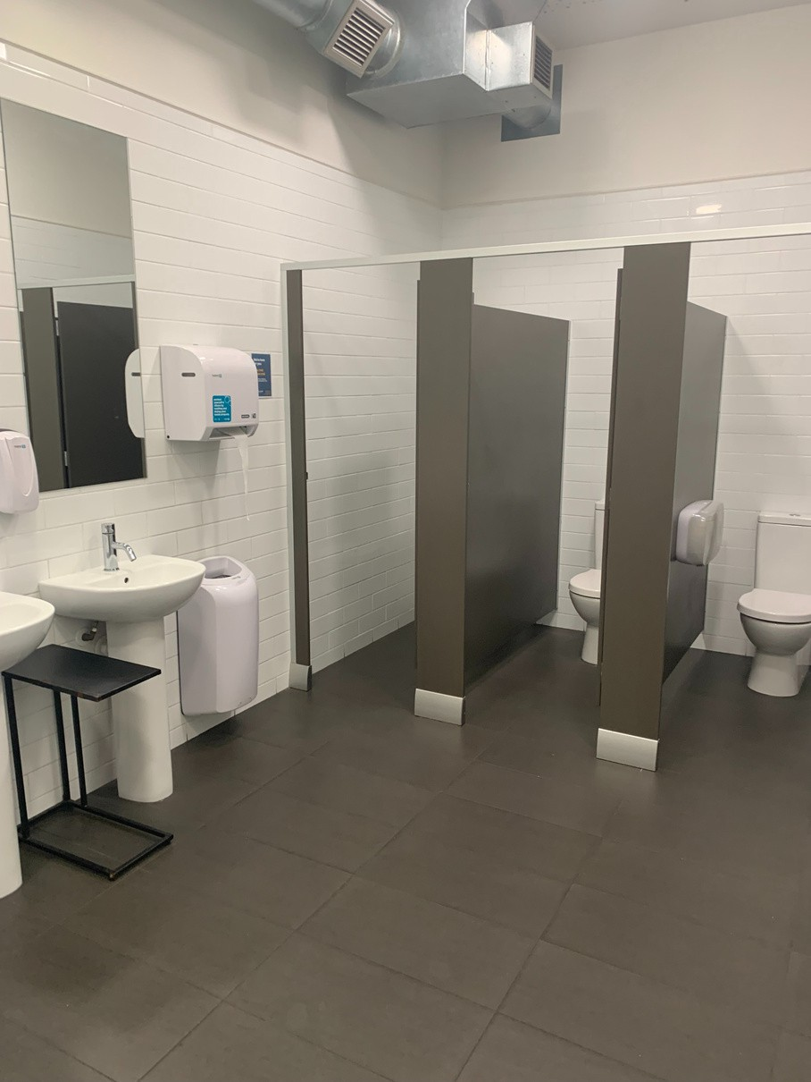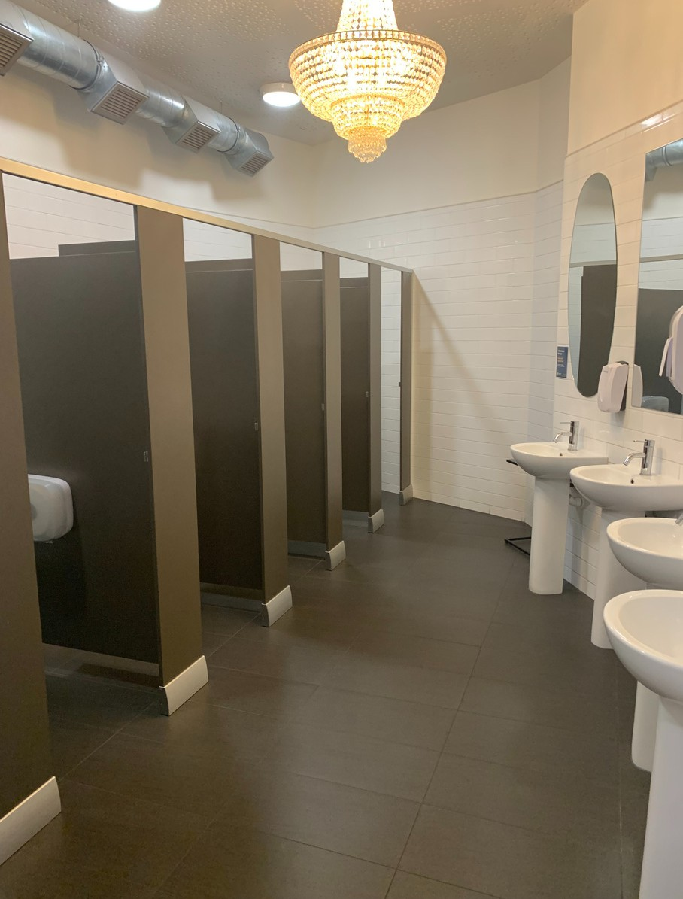

Image 11: Signs on the accessible toilet door
Image 12: Accessible toilet and baby changing area
Image 13: Inside the men’s toilet Image 14: Inside the women’s toilet

The accessible toilet is the first door in the corridor and is well signposted.
The accessible toilet is unisex. It has a railing by the toilet, plenty of room to move and a baby changing table.
The men’s toilet has 3 cubicles, 2 wash basins and a urinal. The women’s toilet has 6 cubicles and 4 wash basins.

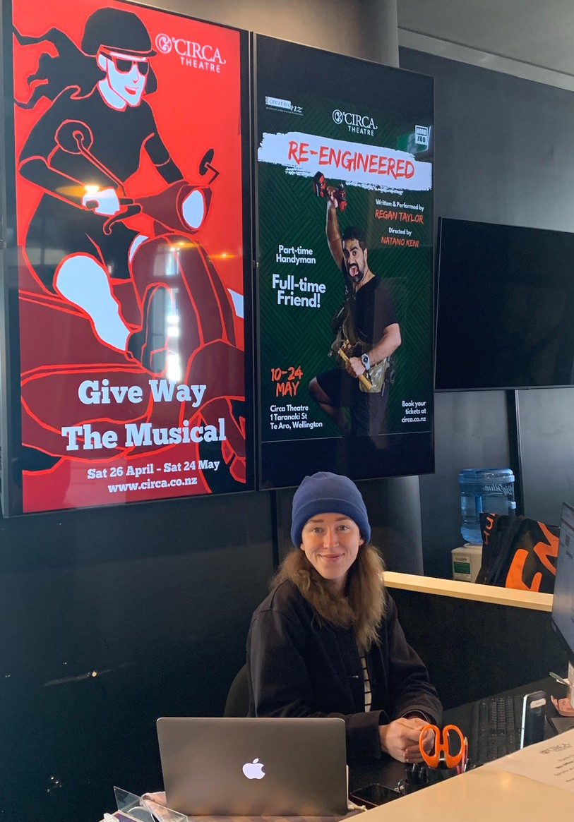
At the Box Office you can buy and collect tickets. Most times an attendant will be sat behind the desk to answer your questions and help you purchase and collect tickets.

Image 15: A box office attendant sits behind the wooden box office desk in front of a laptop. On the wall behind her are large digital posters advertising shows.

Continuing inside is Chouchou café, bar and restaurant which takes up the entire inside foyer. You can purchase meals and drinks, coffee and ice creams here. The cafe can be busy with people dining or buying takeaway coffee and pastries.

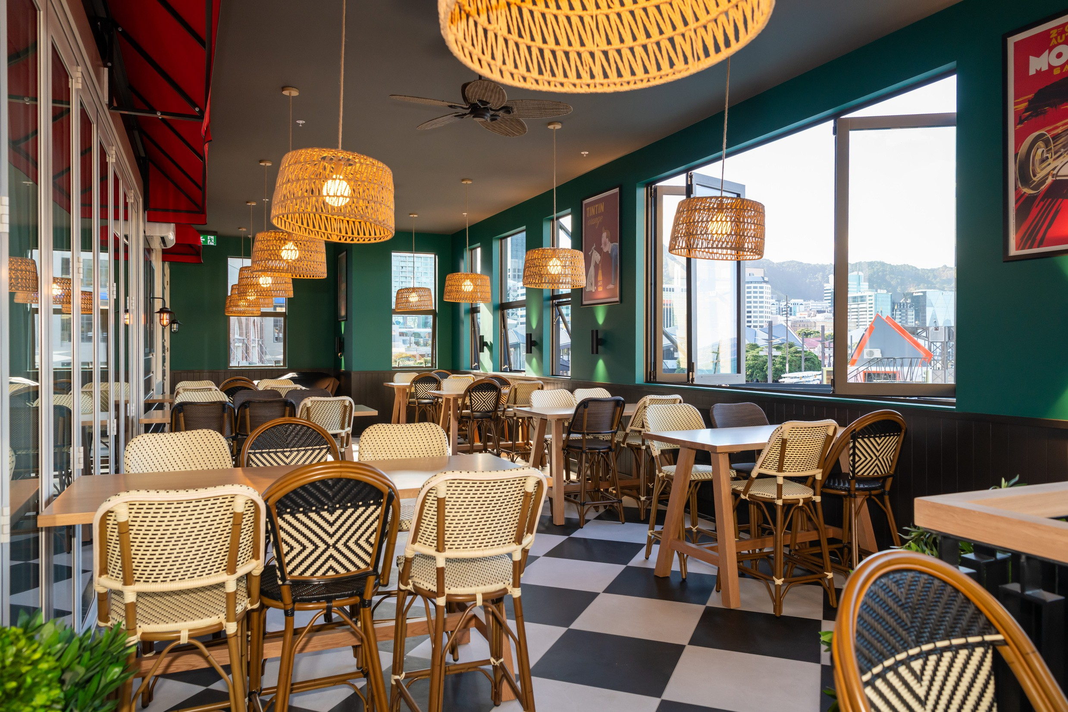
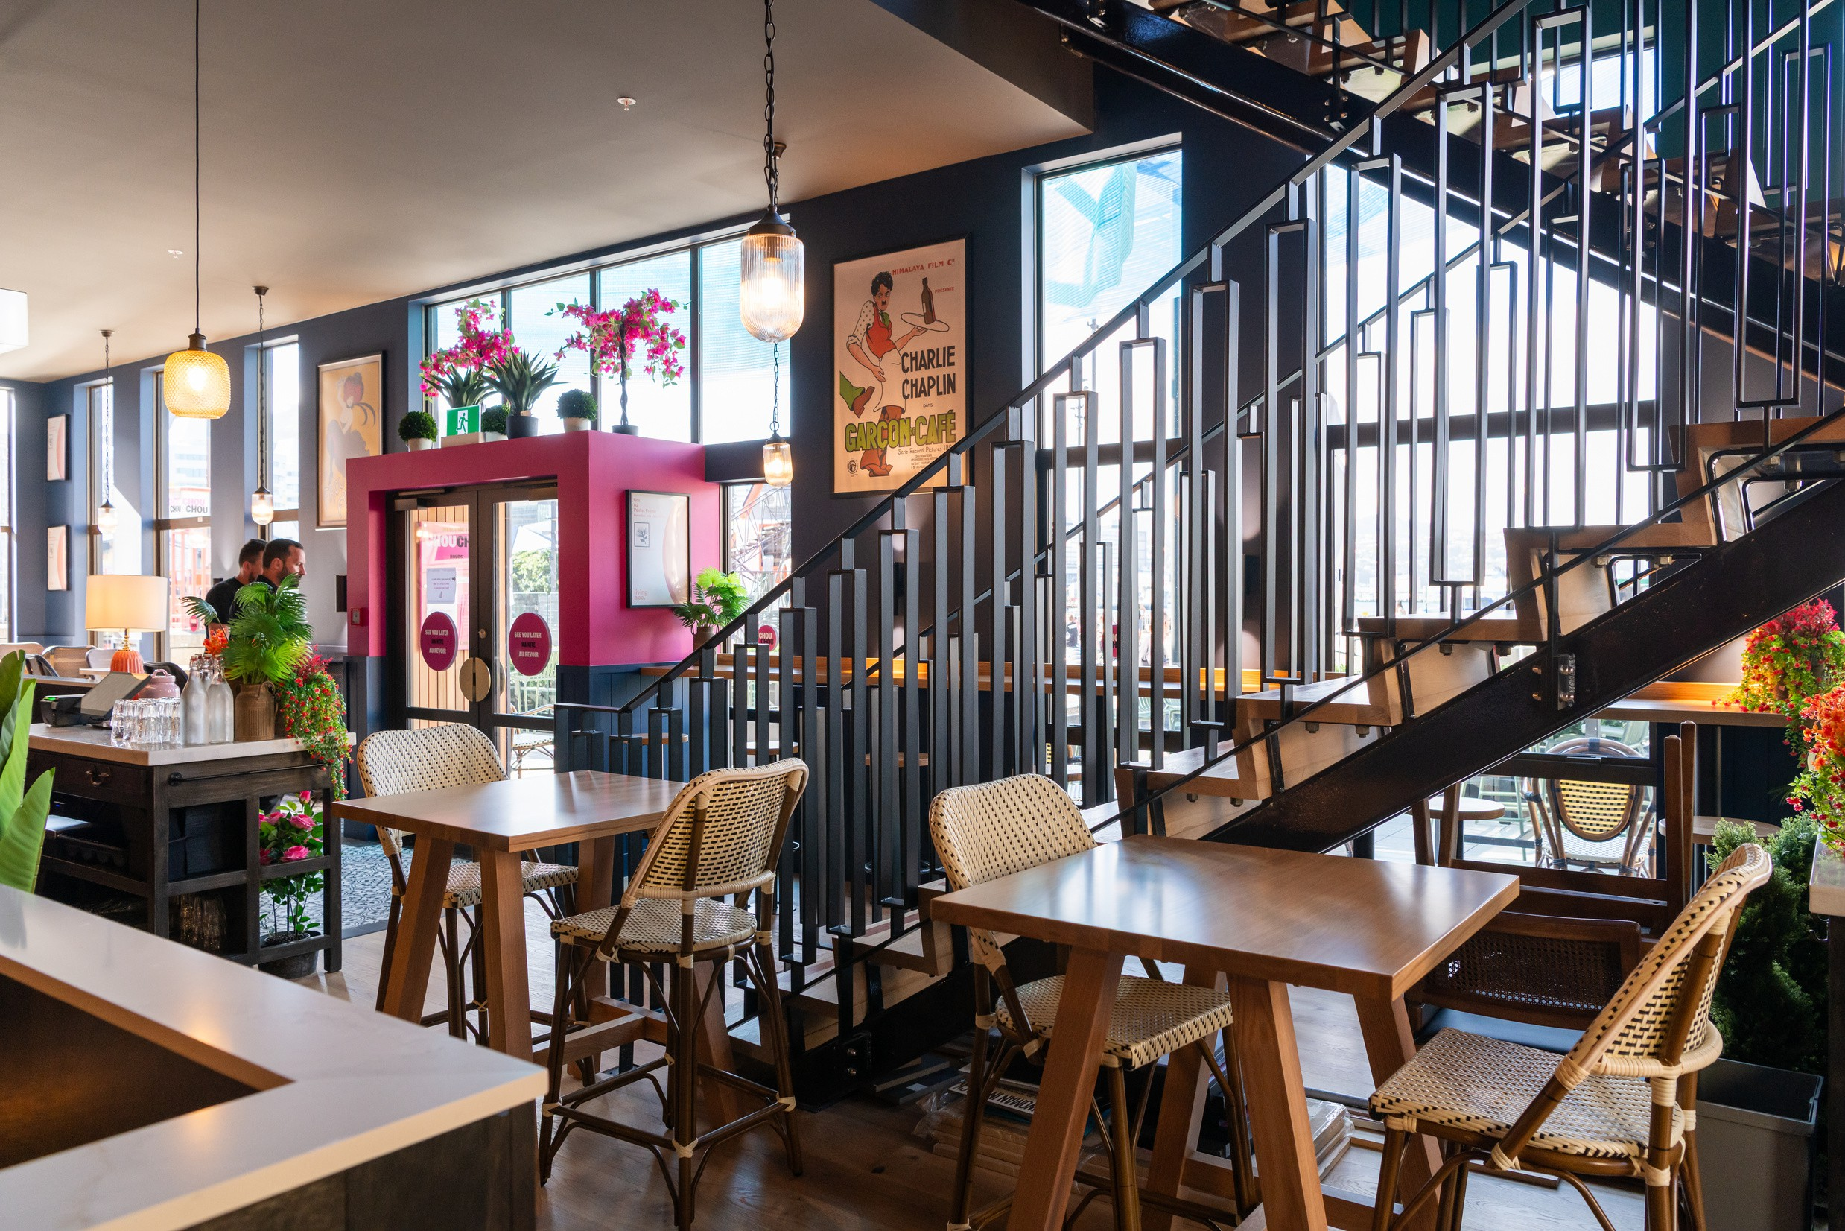

Image 16: Upstairs at Chouchou is a private inside patio with green walls, and rattan chairs and multiple light shades hanging down off the roof.

Image 17: The cafe is decorated in pink, yellow and blue, and has old show posters on the walls. The tables have white marble tops with either single rattan chairs or long felt brown couches on the outside facing in with tables, boxing in the area.

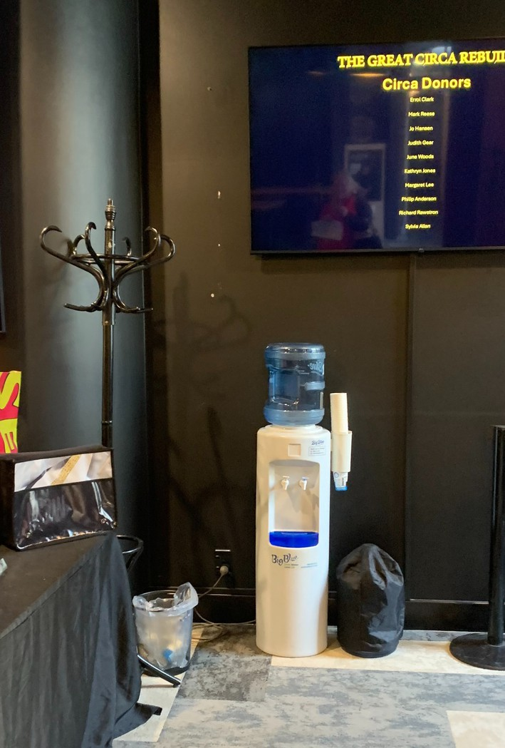

Image 18: The water cooler is located next to the box office, underneath one of the digital screens and next to the table where you can buy Circa merchandise.

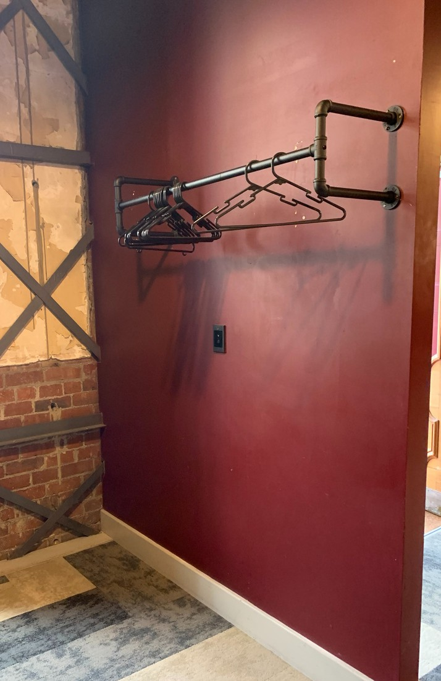

Image 19: A black steel black coat hanger and clothes hangers
On the right of the box office is a water cooler stand, where you can get cool water in paper cups. Facing this against the wall is a coat rack and hangers where you can hang your coat while you are in the restaurant or at a performance.

There are two theatres - Circa One and Circa Two.
Your ticket will tell you which door to go to, and the theatre staff can also help you. All entrances to the theatre are on the ground level. There are thick velvet curtains that are closed when the doors are closed, and open when you can go in and come out of the theatre.
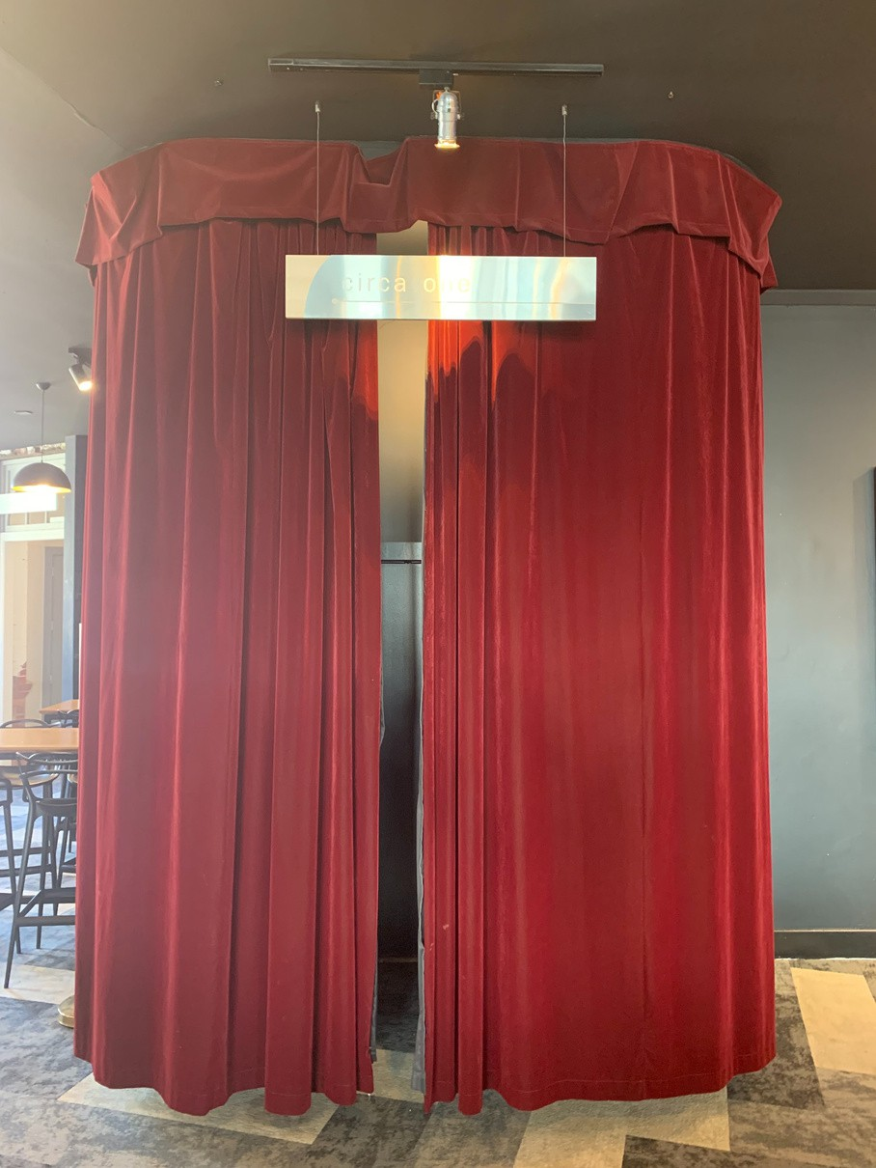
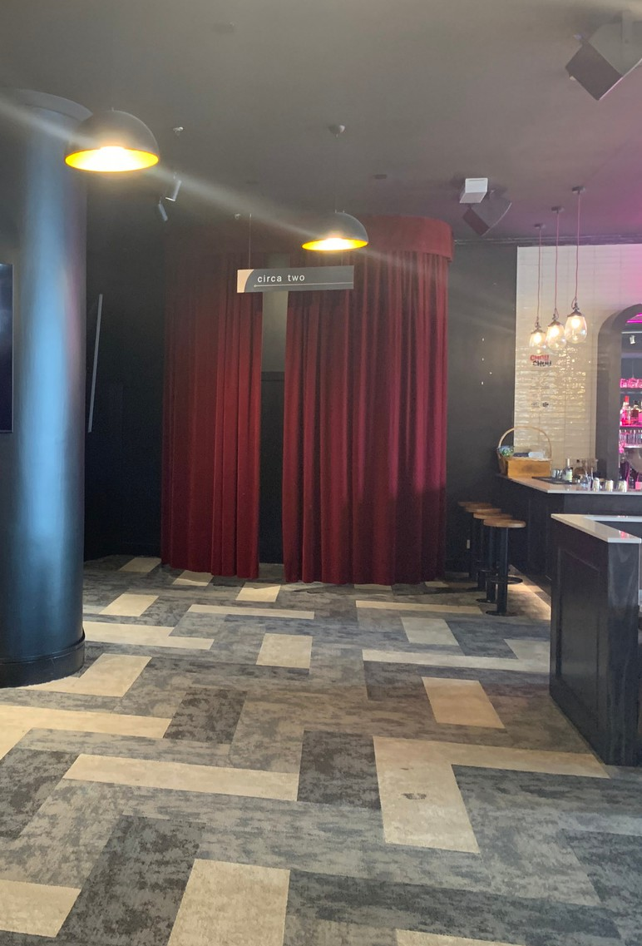
Image 20: Circa One Entrance Way Image 21: Circa Two Entrance Way

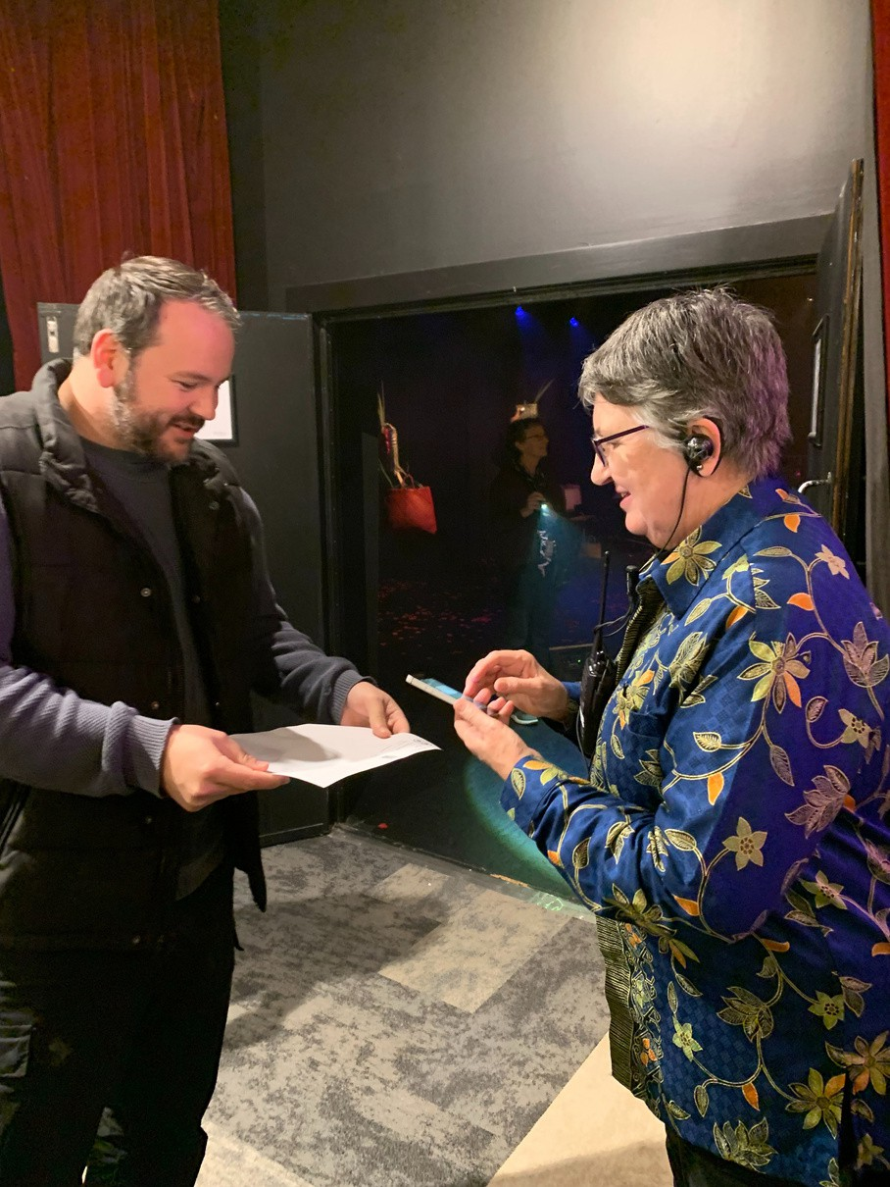
Image 22: An usher scans a ticket of a patron at the open doors as they enter the theatre

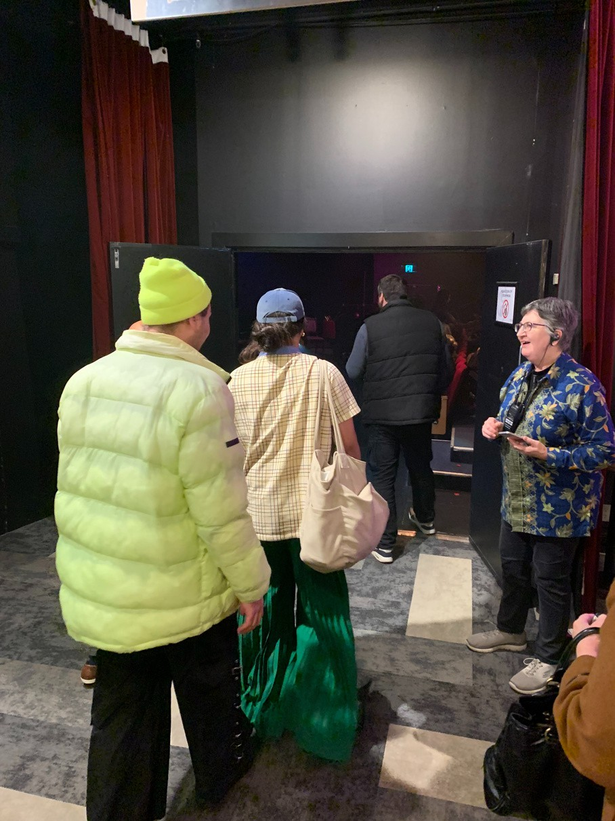
Image 23: Patrons entering the show through the open doors with the usher standing nearby.
The doors will be closed until theatre staff and an announcement let you know that the theatre is open and ready for seating. If you need extra time or assistance to take your seat, please tell theatre staff and they will help you.

When the doors are open, you will show your ticket to the theatre staff to scan, they will be positioned at the door.

Inside the theatres, ushers will be available at the doors and as you enter the stairways to help you find the seats listed on your tickets.
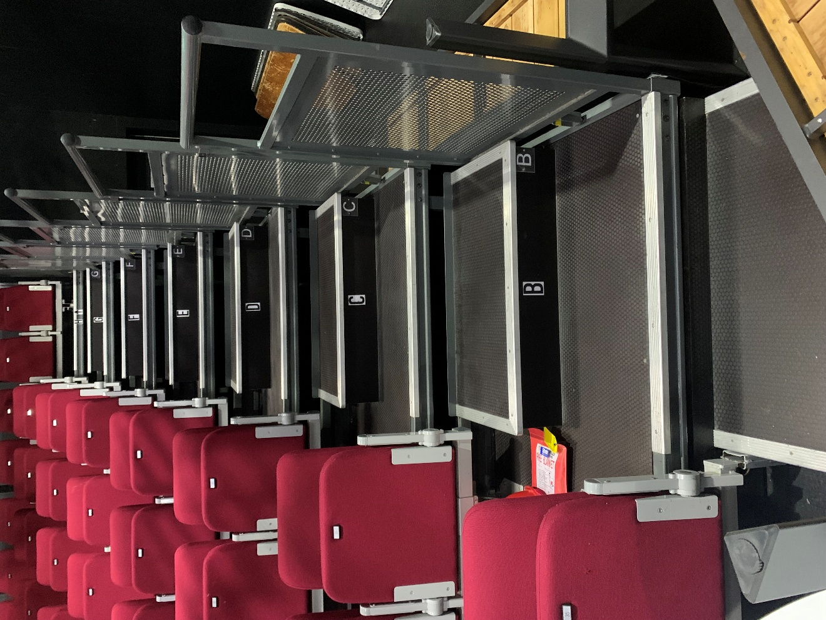
Image 24: Circa One middle section
seating with crimson velvet chairs
Each seat is found on your ticket by a letter which is the row, and a number which is the seat. There are little numbers on the physical seats and the letters are found on the floor at the start of each row.

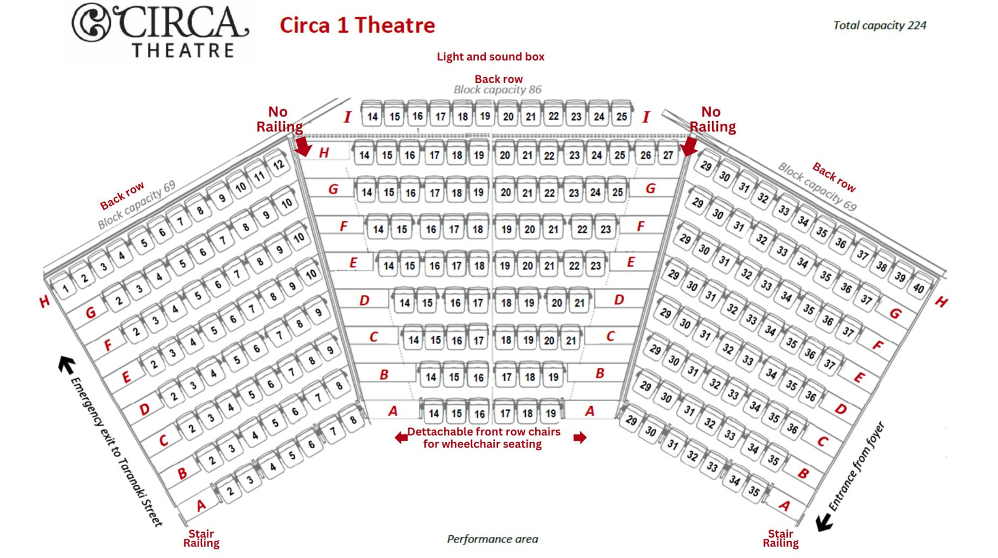
Circa One Theatre - Layout
Your seat is found with the row letter and seat number on your ticket. Rows start at the floor level ‘A’ and is best if you do not want to go up any stairs. The top row finishes at row ‘H’.

The seat numbers are consecutive from left to right when looking at the seating blocks from the stage. The outer seats are best if you need the railing and start at seat numbers #2 & #3 and #35 & #36.
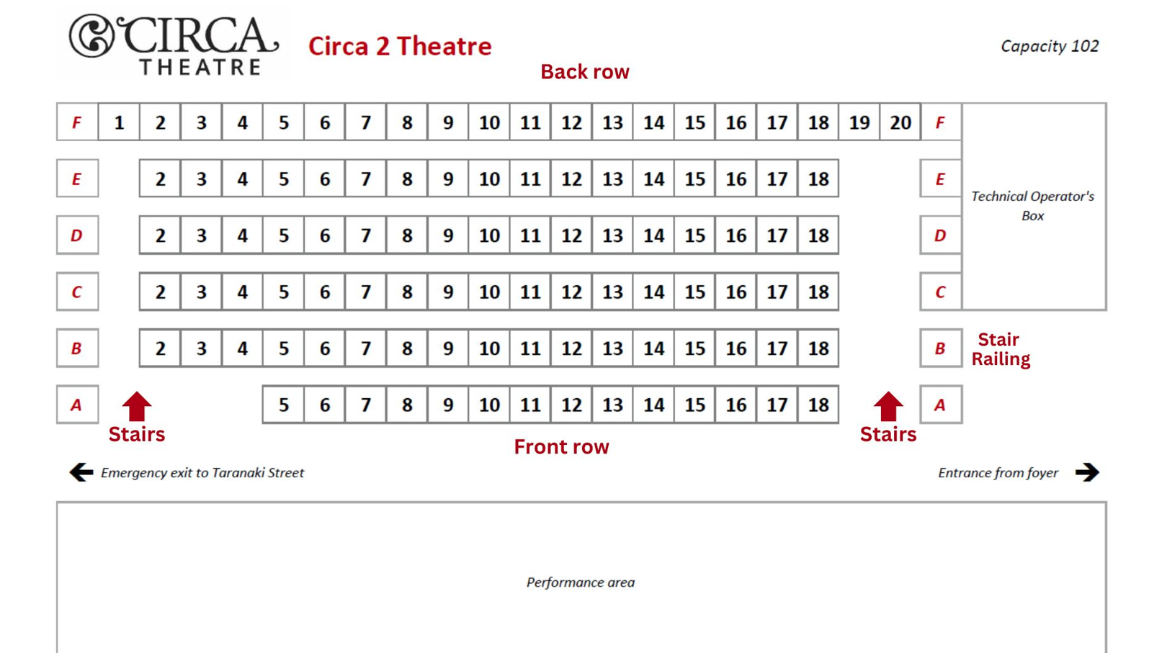
Circa Two Theatre - Layout
Your seat is found with the row letter and seat number on your ticket.
Rows start at the floor level ‘A’ and is best if you do not want to go up any stairs. The top row finishes at row ‘F’.
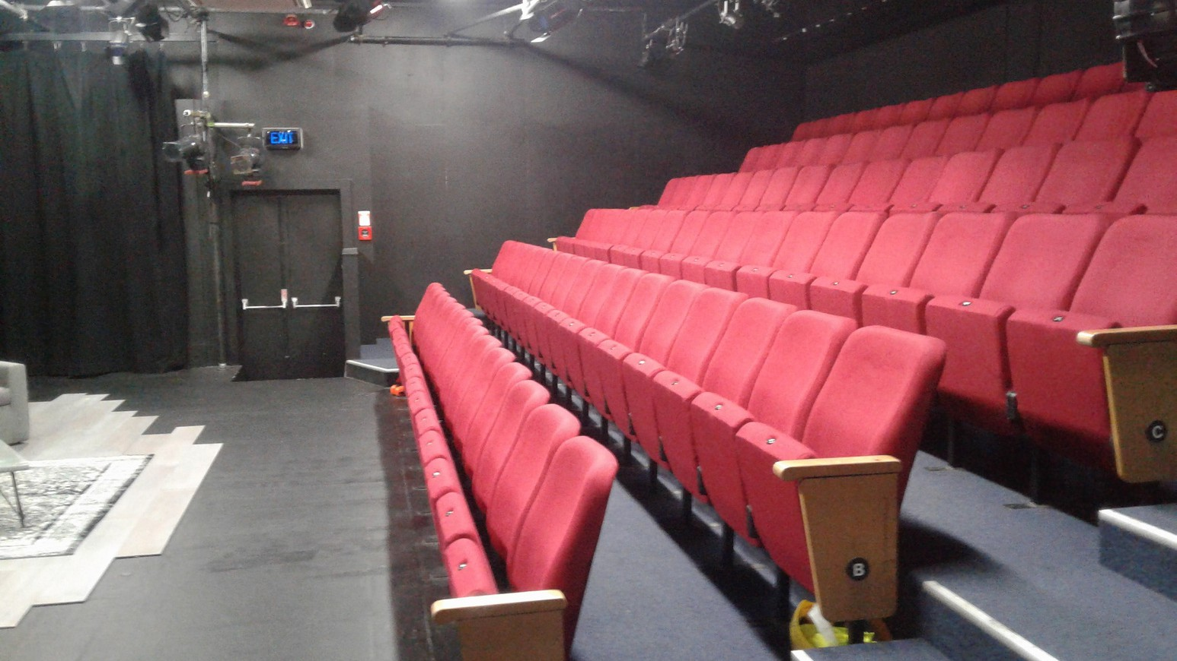
Image 25: Circa Two red velvet chair seats with a small stage
In Circa Two the accessible seating is in the front row. The theatre only holds 100 people and is in an intimate setting.
The front row of seats provides the most accessible seating, as it is a flat surface from the foyer to these seats, with no inclines or stairs.

Each theatre has isles which are configured slightly differently. The stairs are approx. 15cm high. In Circa One the seating block has 4 stairways. There is no railing in the two inner stairways, only on the outside stairways.
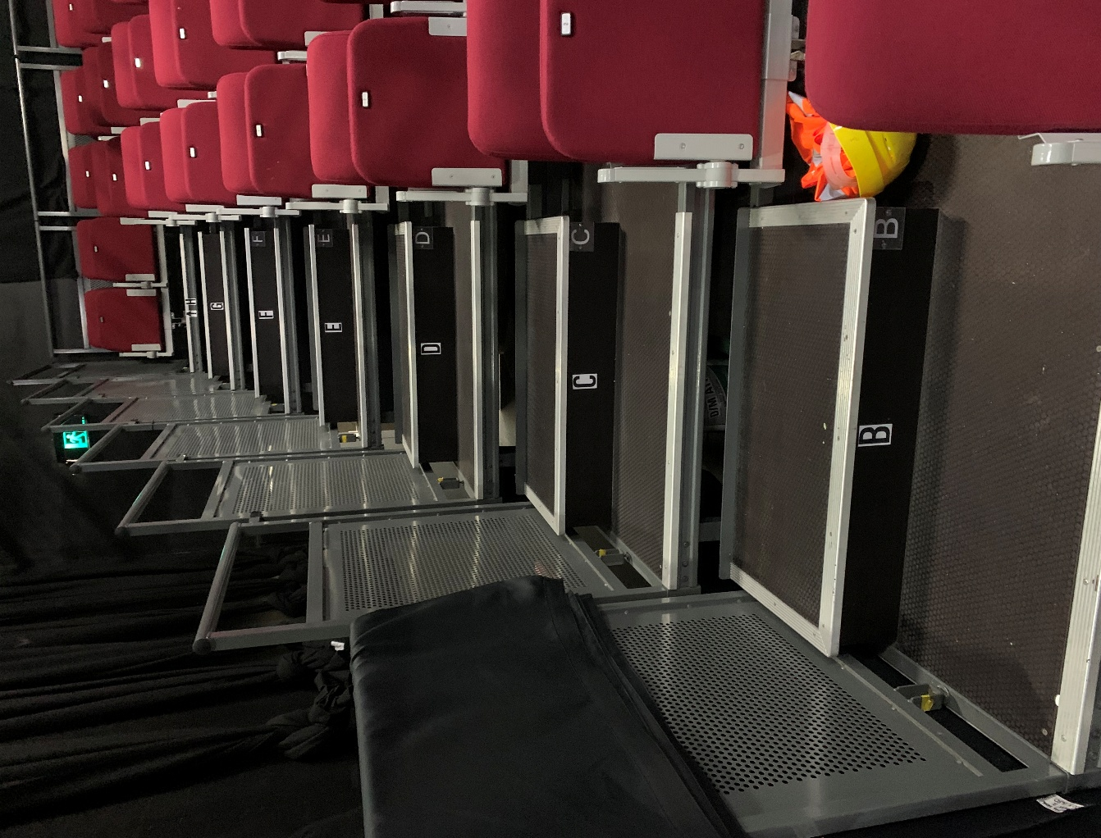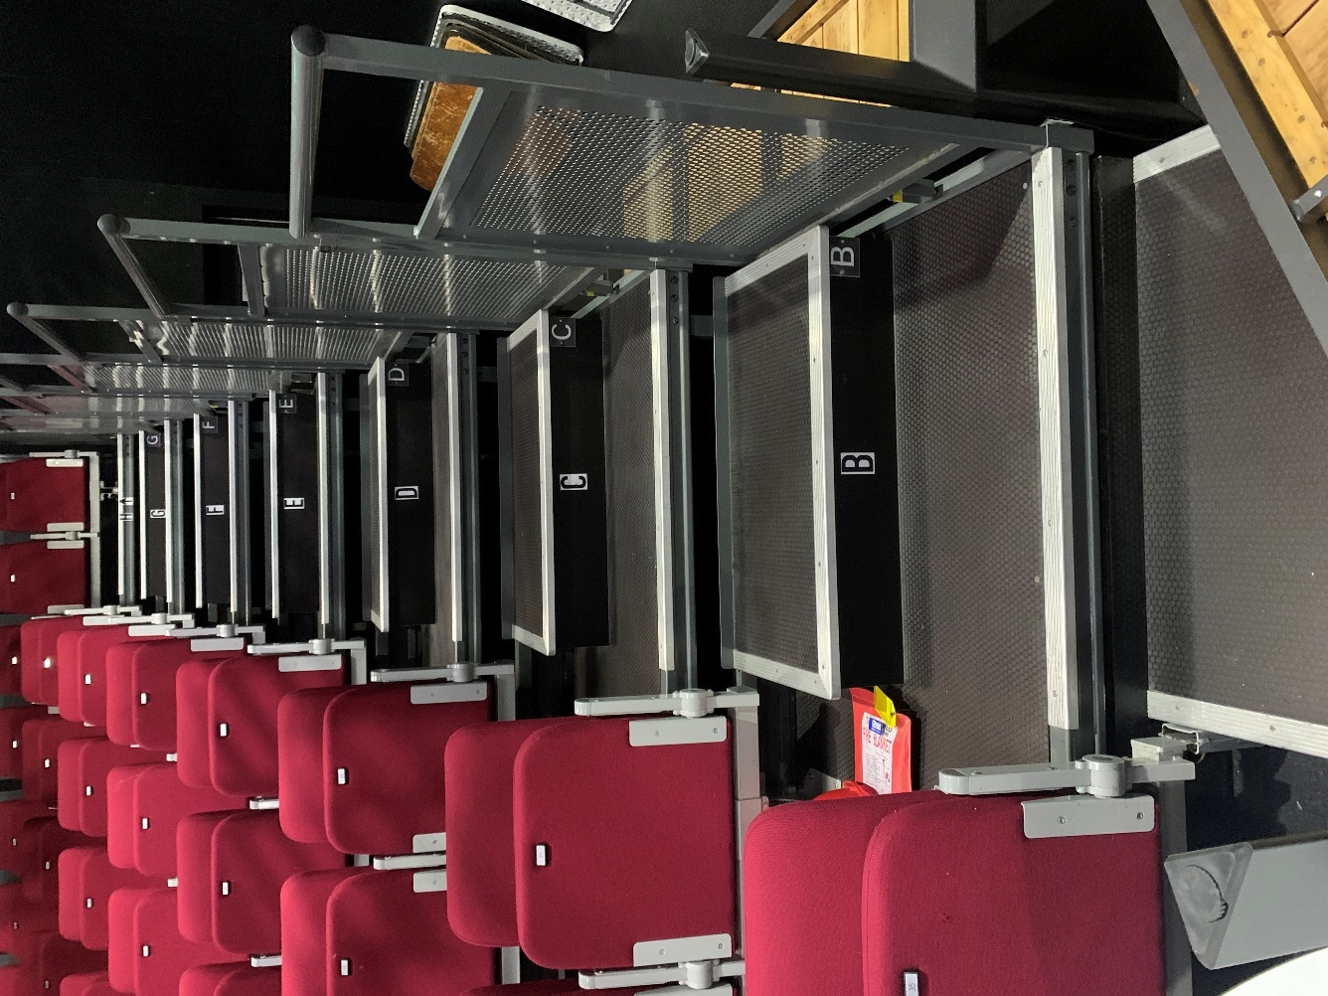
Image 26: Steps are 15cm high and generally 90cm (w) x 43cm (l)
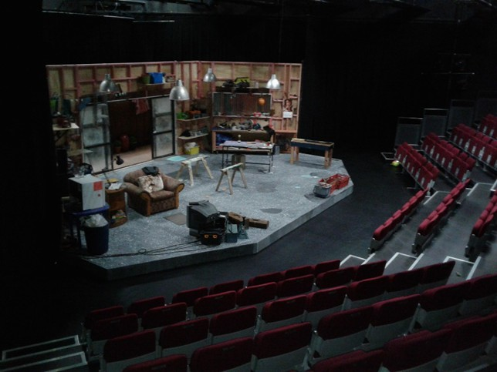
When the show is ready to begin, the lights will go dark on the seats and turn on the stage. In shows people may clap and cheer if they like something and are free to express a range of emotions reflecting how the play makes them feel. You can wear earplugs if you need to.
Image 26: The set of a show with seating facing the stage
Some shows have an interval, and the audience may leave the theatre during this time. During the interval it is a good time to go to the bathroom, get water, an ice cream, or anything else you may want. There could be a queue for toilets or when getting food and drinks at the bar, there may also be diner’s in the restaurant.

At the end of the show, you’ll exit the same way you enter after the audience claps the actors. They may even get a standing ovation when everyone stands up to clap, and an encore when the cast is called back on stage by the audience for another final act or song before finishing.

You are welcome to stay in your seat until the crowd leaves and then exit.

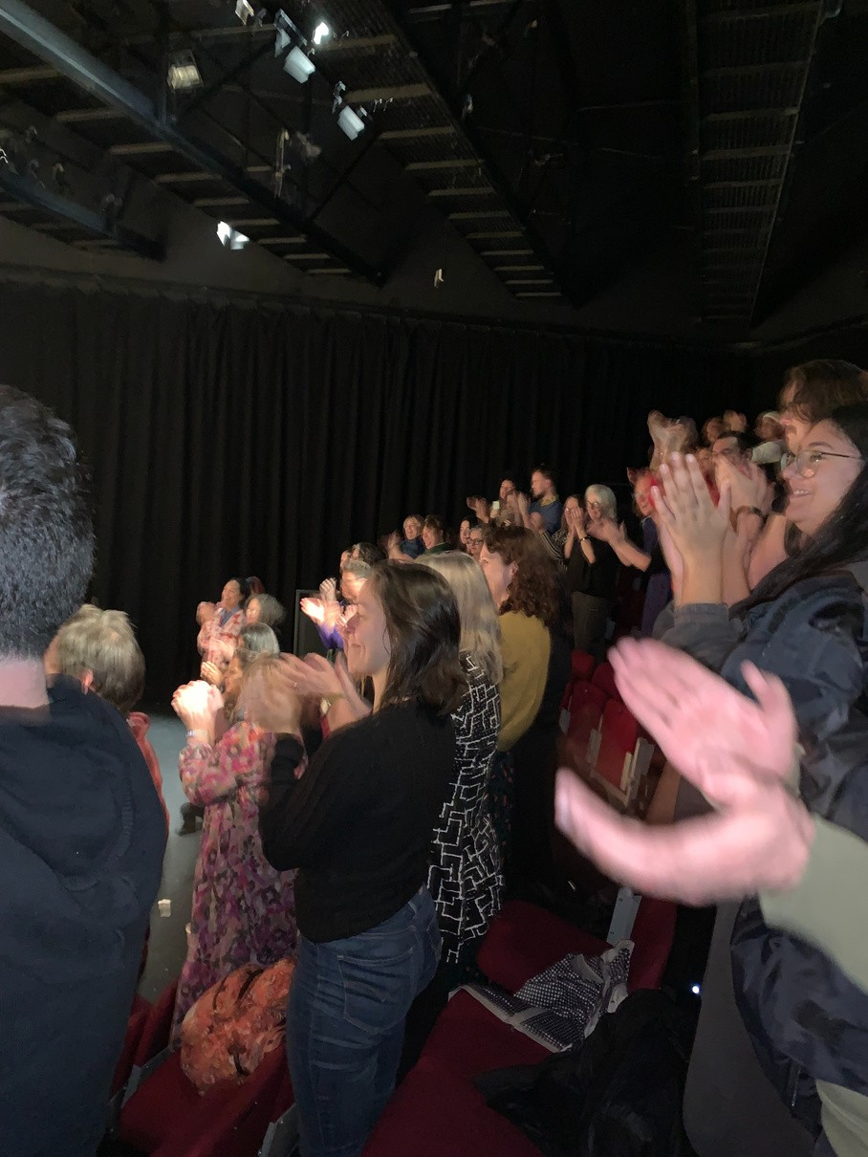
Image 27: The audience standing up
and clapping performers after a show.

Thank you for joining us at Circa Theatre. We are excited about seeing you soon.

Ka kite!

Win 2 tickets to a Circa show
Answer these two questions and go in to win:
- Did you read this entire document?
- What did you think of it?

Send your answer to marketingmanager@circa.co.nz.
One winner is chosen every month.
Winners will be notified by email within 7 days of the month close.

